QUESTION 1

CODE

*\*&---------------------------------------------------------------------\**  
*\*& Report ZALFY_FINAL_ALV*  
*\*&---------------------------------------------------------------------\**  
*\*&*  
*\*&---------------------------------------------------------------------\**  
REPORT zalfy_final_alv.  
TYPES : BEGIN OF ty_marc,  
 matnr TYPE marc-matnr,  
 werks TYPE marc-werks,  
 END OF ty_marc.  
DATA : v_matnr TYPE matnr,  
 o_alv TYPE REF TO cl_salv_table,  
 it_marc TYPE STANDARD TABLE OF ty_marc.  
SELECT-OPTIONS s_matnr FOR v_matnr.  
SELECT matnr werks FROM marc INTO TABLE it_marc WHERE MATNR IN S_MATNR.  
  
TRY.  
 cl_salv_table=>factory(  
*\* EXPORTING*  
*\* list_display = if_salv_c_bool_sap=>false " ALV Displayed in List Mode*  
*\* r_container = " Abstract Container for GUI Controls*  
*\* container_name =*  
 IMPORTING  
 r_salv_table = o_alv *" Basis Class Simple ALV Tables*  
 CHANGING  
 t_table = it_marc  
 ).  
 CATCH cx_salv_msg. *" ALV: General Error Class with Message*  
ENDTRY.  
o_alv->display( ).  
*\*o_alv->get_columns(*  
*\* RECEIVING*  
*\* value =*  
*\*).*

OUTPUT

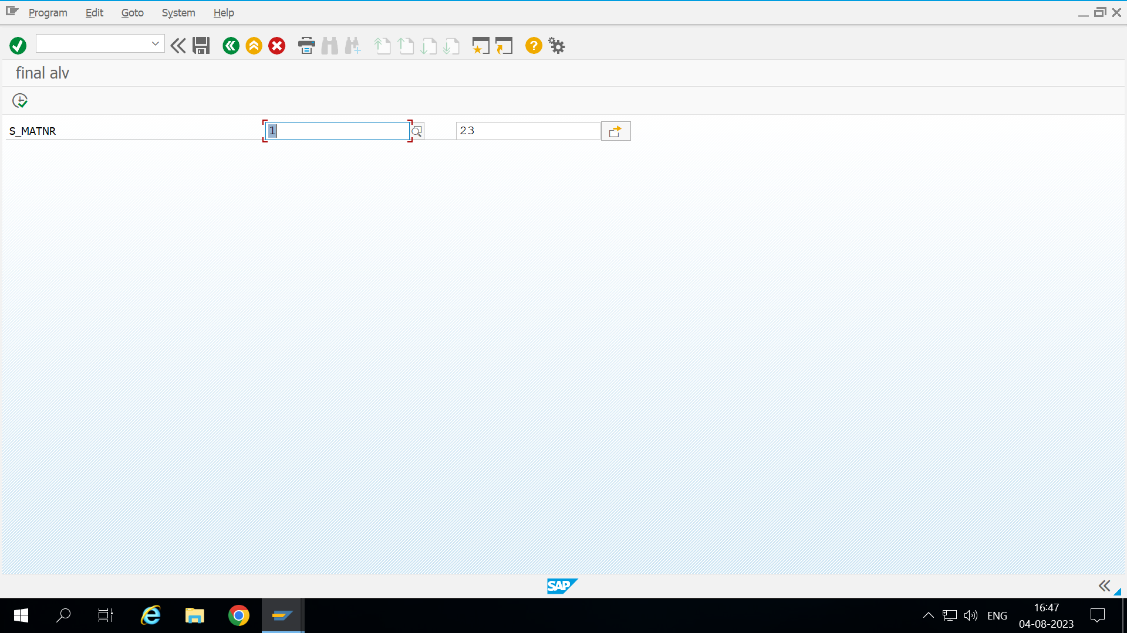

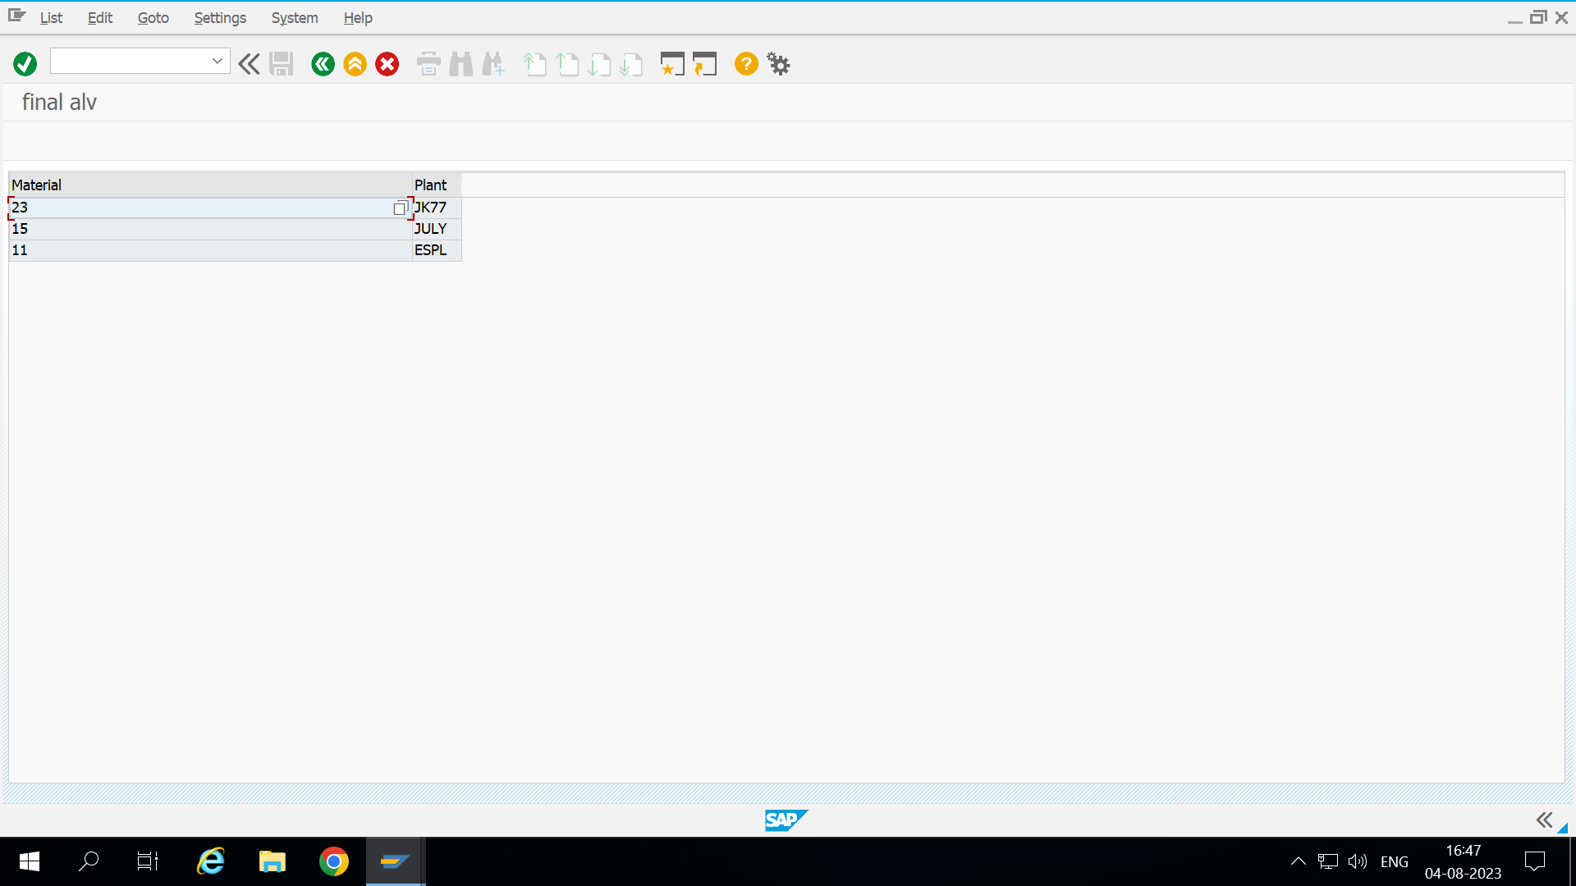

QUESTON 2.

CODE

*&---------------------------------------------------------------------*  
*& Report ZALFY_FINAL_BADI  
*&---------------------------------------------------------------------*  
*&  
*&---------------------------------------------------------------------*  
REPORT zalfy_final_badi.  
DATA o_badi TYPE REF TO zbadi_defin.  
PARAMETERS v_value type i.  
GET BADI o_badi.  
call badi o_badi->cal_tax  
  EXPORTING  
    v_val   = v_value  
  
  .

OUTPUT

